22.23: The point is inside the sphere, so 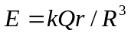(Example 22.9)

